Springboard Intensive Data Science Course

Breast Cancer Classification Project

Final Report

20 March 2017

Mentor: Pavitraa Parthasarathy

Student: Jing-Rui Li

Final project requirement:

Github code: https://github.com/jl3392/Capstone-Design/blob/master/final_project_code.ipynb

**1.Introduction - Background**

Breast cancer is one of the most dangerous form of cancers in the world. Annually, Breast caner kills an estimated 20,000 people in the US. If breast cancer is recognized and treated early, it is almost curable, with a 80 to 90% 5-year survival rate when treated with simple excision. Early diagnosis of the breast cancer will help save thousands of lives.

The Breast Cancer project aims to develop a system that takes breast features as inputs, and outputs the likelihood that the patient is malignant, in order to facilitate early diagnosis of breast cancer. Unique and relevant features such as statistical measures (mean, standard deviation and covariance) of the breast's shape information (area, diameter, compactness and asymmetry) was extracted from the pre-processed images. Texture information, obtained from a gray level covariance matrix was also included. A trained classifier will then compute the likelihood that the lesion is malignant and return this percentage to the user.

Link to the dataset:

<http://scikit-learn.org/stable/modules/generated/sklearn.datasets.load_breast_cancer.html>

**2. Dataset**

This project uses the Breast Cancer Wisconsin (Diagnostic) Database to create a classifier that can help diagnose patients. Features are computed from a digitized image of a fine needle aspirate (FNA) of a breast mass. They describe characteristics of the cell nuclei present in the image. The dataset of the breast cancer information can be accessed from build-in python package sklearn.dataset.load_breast_cancer. (Link to the dataset:

<http://scikit-learn.org/stable/modules/generated/sklearn.datasets.load_breast_cancer.html)>.

**Data Set Characteristics:**

:Number of Instances: 569

:Number of Attributes: 30 numeric, predictive attributes and the class

:Attribute Information:

- radius (mean of distances from center to points on the perimeter)

- texture (standard deviation of gray-scale values)

- perimeter

- area

- smoothness (local variation in radius lengths)

- compactness (perimeter^2 / area - 1.0)

- concavity (severity of concave portions of the contour)

- concave points (number of concave portions of the contour)

- symmetry

- fractal dimension ("coastline approximation" - 1)

The mean, standard error, and "worst" or largest (mean of the three

largest values) of these features were computed for each image,

resulting in 30 features. For instance, field 3 is Mean Radius, field

13 is Radius SE, field 23 is Worst Radius.

- class:

- WDBC-Malignant

- WDBC-Benign

:Summary Statistics:

===================================== ====== ======

Min Max

===================================== ====== ======

radius (mean): 6.981 28.11

texture (mean): 9.71 39.28

perimeter (mean): 43.79 188.5

area (mean): 143.5 2501.0

smoothness (mean): 0.053 0.163

compactness (mean): 0.019 0.345

concavity (mean): 0.0 0.427

concave points (mean): 0.0 0.201

symmetry (mean): 0.106 0.304

fractal dimension (mean): 0.05 0.097

radius (standard error): 0.112 2.873

texture (standard error): 0.36 4.885

perimeter (standard error): 0.757 21.98

area (standard error): 6.802 542.2

smoothness (standard error): 0.002 0.031

compactness (standard error): 0.002 0.135

concavity (standard error): 0.0 0.396

concave points (standard error): 0.0 0.053

symmetry (standard error): 0.008 0.079

fractal dimension (standard error): 0.001 0.03

radius (worst): 7.93 36.04

texture (worst): 12.02 49.54

perimeter (worst): 50.41 251.2

area (worst): 185.2 4254.0

smoothness (worst): 0.071 0.223

compactness (worst): 0.027 1.058

concavity (worst): 0.0 1.252

concave points (worst): 0.0 0.291

symmetry (worst): 0.156 0.664

fractal dimension (worst): 0.055 0.208

===================================== ====== ======

:Missing Attribute Values: None

:Class Distribution: 212 - Malignant, 357 - Benign

:Creator: Dr. William H. Wolberg, W. Nick Street, Olvi L. Mangasarian

:Donor: Nick Street

:Date: November, 1995

This is a copy of UCI ML Breast Cancer Wisconsin (Diagnostic) datasets.

<https://goo.gl/U2Uwz2>

References

----------

- W.N. Street, W.H. Wolberg and O.L. Mangasarian. Nuclear feature extraction

for breast tumor diagnosis. IS&T/SPIE 1993 International Symposium on

Electronic Imaging: Science and Technology, volume 1905, pages 861-870,

San Jose, CA, 1993.

- O.L. Mangasarian, W.N. Street and W.H. Wolberg. Breast cancer diagnosis and

prognosis via linear programming. Operations Research, 43(4), pages 570-577,

July-August 1995.

- W.H. Wolberg, W.N. Street, and O.L. Mangasarian. Machine learning techniques

to diagnose breast cancer from fine-needle aspirates. Cancer Letters 77 (1994)

163-171.

**3. Data Visualization and Pre-processing**

Firstly, Let's take a look at the number of Benign and Maglinant cases from the dataset. From the output shown below, there are 357 cases are benign while 212 cases are malignant.

print(df.groupby('diagnosis').size())

diagnosis

0 212

1 357

Next, I visualized the data using density plots to get a sense of the data distribution.

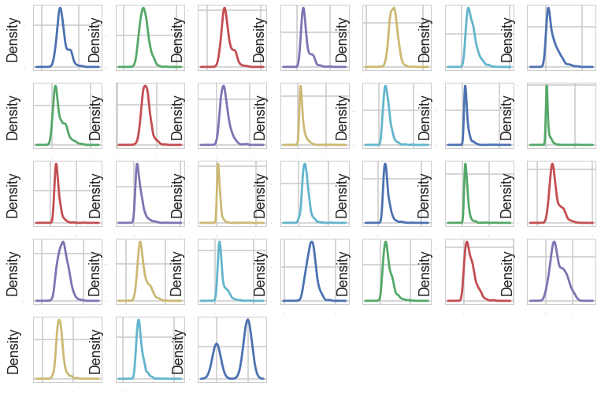

Figure X

From the outputs above, we can see the data shows a general Gaussian distribution.

Then, It is good to check the correlations between the attributes.

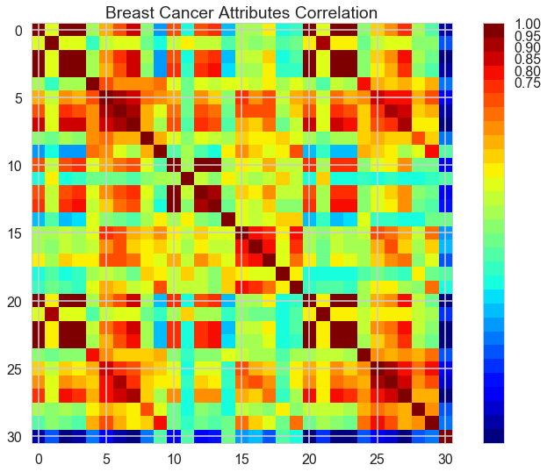

Figure X

From the output graph below, The red around the diagonal suggests that attributes are correlated with each other. The yellow and green patches suggest some moderate correlation and the blue boxes show negative correlations.

**3. Baseline Algorithm Checking**

From the dataset, we will analysis and build a model to predict if a given set of symptoms lead to breast cancer. This is a binary classification problem, and a few algorithms are appropriate for use. Since we do not know which one will perform the best at the point, we will do a quick test on the few appropriate algorithms with default setting to get an early indication of how each of them perform. We will use 10 fold cross validation for each testing.

The following non-linear algorithms will be used, namely: Classification and Regression Trees (CART), Linear Support Vector Machines (SVM), Gaussian Naive Bayes (NB) and k-Nearest Neighbors (KNN).

CART: 0.912077 (0.041922) (run time: 0.070305)

SVM: 0.619614 (0.082882) (run time: 0.119033)

NB: 0.940773 (0.033921) (run time: 0.011583)

KNN: 0.927729 (0.055250) (run time: 0.017861)

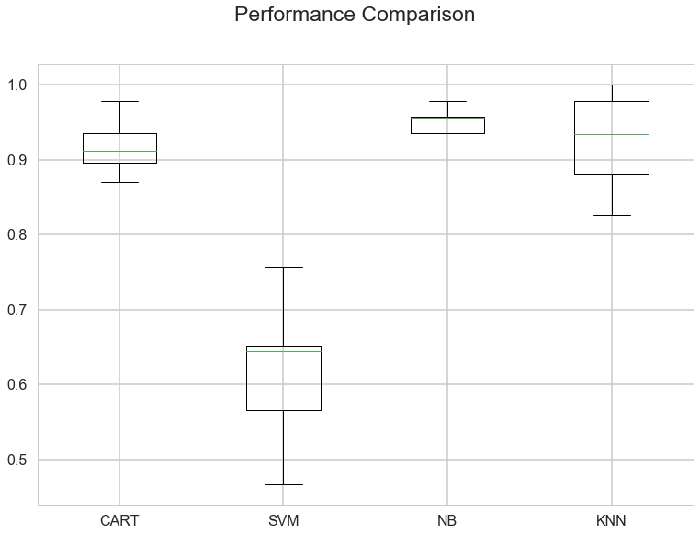

Figure X

From the initial run, it looks like Gaussian NB, KNN and CART performed the best given the dataset (all above 92% mean accuracy). Support Vector Machine has a surprisingly bad performance here. However, if we standardize the input dataset, it's performance should improve.

The performance of the few machine learning algorithm could be improved if a standardized dataset is being used. The improvement is likely for all the models. I will use pipelines that standardize the data and build the model for each fold in the cross-validation test harness. That way we can get a fair estimation of how each model with standardized data might perform on unseen data.

ScaledCART: 0.914396 (0.037331) (run time: 0.113696)

ScaledSVM: 0.964879 (0.038621) (run time: 0.074927)

ScaledNB: 0.931932 (0.038625) (run time: 0.033946)

ScaledKNN: 0.958357 (0.038595) (run time: 0.053220)

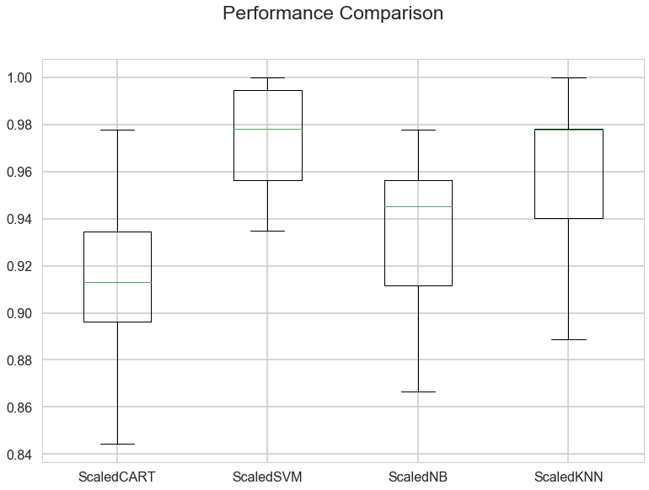

Figure X

From the performance figure above, we can see the SVM algorithm has a great improvement with the standardized data.

Thus, I decide to focus on SVM for the algorithm tuning. We can tune two key parameter of the SVM algorithm - the value of C and the type of kernel. The default C for SVM is 1.0 and the kernel is Radial Basis Function (RBF). We will use the grid search method using 10-fold cross-validation with a standardized copy of the sample training dataset. We will try over a combination of C values and the following kernel types 'linear', 'poly', 'rbf' and 'sigmoid’.

Best: 0.969231 using {'C': 2.0, 'kernel': 'rbf'}

0.964835 (0.026196) with: {'C': 0.1, 'kernel': 'linear'}

0.826374 (0.058723) with: {'C': 0.1, 'kernel': 'poly'}

0.940659 (0.038201) with: {'C': 0.1, 'kernel': 'rbf'}

0.949451 (0.032769) with: {'C': 0.1, 'kernel': 'sigmoid'}

0.962637 (0.029474) with: {'C': 0.3, 'kernel': 'linear'}

0.868132 (0.051148) with: {'C': 0.3, 'kernel': 'poly'}

0.958242 (0.031970) with: {'C': 0.3, 'kernel': 'rbf'}

0.953846 (0.043579) with: {'C': 0.3, 'kernel': 'sigmoid'}

0.956044 (0.030933) with: {'C': 0.5, 'kernel': 'linear'}

0.881319 (0.050677) with: {'C': 0.5, 'kernel': 'poly'}

0.964835 (0.029906) with: {'C': 0.5, 'kernel': 'rbf'}

0.953846 (0.026785) with: {'C': 0.5, 'kernel': 'sigmoid'}

0.953846 (0.031587) with: {'C': 0.7, 'kernel': 'linear'}

0.885714 (0.038199) with: {'C': 0.7, 'kernel': 'poly'}

0.967033 (0.037271) with: {'C': 0.7, 'kernel': 'rbf'}

0.953846 (0.028513) with: {'C': 0.7, 'kernel': 'sigmoid'}

0.951648 (0.028834) with: {'C': 0.9, 'kernel': 'linear'}

0.887912 (0.038950) with: {'C': 0.9, 'kernel': 'poly'}

0.967033 (0.037271) with: {'C': 0.9, 'kernel': 'rbf'}

0.958242 (0.033272) with: {'C': 0.9, 'kernel': 'sigmoid'}

0.953846 (0.026546) with: {'C': 1.0, 'kernel': 'linear'}

0.890110 (0.038311) with: {'C': 1.0, 'kernel': 'poly'}

0.967033 (0.033027) with: {'C': 1.0, 'kernel': 'rbf'}

0.964835 (0.031496) with: {'C': 1.0, 'kernel': 'sigmoid'}

0.956044 (0.025765) with: {'C': 1.3, 'kernel': 'linear'}

0.894505 (0.039427) with: {'C': 1.3, 'kernel': 'poly'}

0.967033 (0.028188) with: {'C': 1.3, 'kernel': 'rbf'}

0.958242 (0.033224) with: {'C': 1.3, 'kernel': 'sigmoid'}

0.958242 (0.024765) with: {'C': 1.5, 'kernel': 'linear'}

0.896703 (0.039791) with: {'C': 1.5, 'kernel': 'poly'}

0.967033 (0.028188) with: {'C': 1.5, 'kernel': 'rbf'}

0.945055 (0.034215) with: {'C': 1.5, 'kernel': 'sigmoid'}

0.956044 (0.021766) with: {'C': 1.7, 'kernel': 'linear'}

0.903297 (0.033409) with: {'C': 1.7, 'kernel': 'poly'}

0.967033 (0.024479) with: {'C': 1.7, 'kernel': 'rbf'}

0.956044 (0.035354) with: {'C': 1.7, 'kernel': 'sigmoid'}

0.956044 (0.021766) with: {'C': 2.0, 'kernel': 'linear'}

0.909890 (0.033680) with: {'C': 2.0, 'kernel': 'poly'}

0.969231 (0.022370) with: {'C': 2.0, 'kernel': 'rbf'}

0.947253 (0.028116) with: {'C': 2.0, 'kernel': 'sigmoid'}

We can see the most accurate configuration was SVM with an RBF kernel and C=2.0, with the accuracy of 96.92%.

**4. Applying various forecasting models**

**4.1 SVM Analysis**

Accuracy score 0.991228

precision recall f1-score support

0 0.97 1.00 0.99 39

1 1.00 0.99 0.99 75

avg / total 0.99 0.99 0.99 114

print(confusion_matrix(Y_test, predictions))

[[39 0]

[ 1 74]]

We can see that we achieve an accuracy of 99.1% on the held-out test dataset. From the confusion matrix, there is only 1 case of mis-classification. The performance of this algorithm is expected to be high given the symptoms for breast cancer should exhibit certain clear patterns.

**4.2 Random Forest Analysis**

Firstly, we would like to rank the importance of the features.

importance

feature

mean concave points 0.263

mean area 0.183

mean concavity 0.162

mean perimeter 0.153

mean radius 0.069

mean compactness 0.067

mean texture 0.052

mean smoothness 0.019

mean symmetry 0.019

mean fractal dimension 0.013

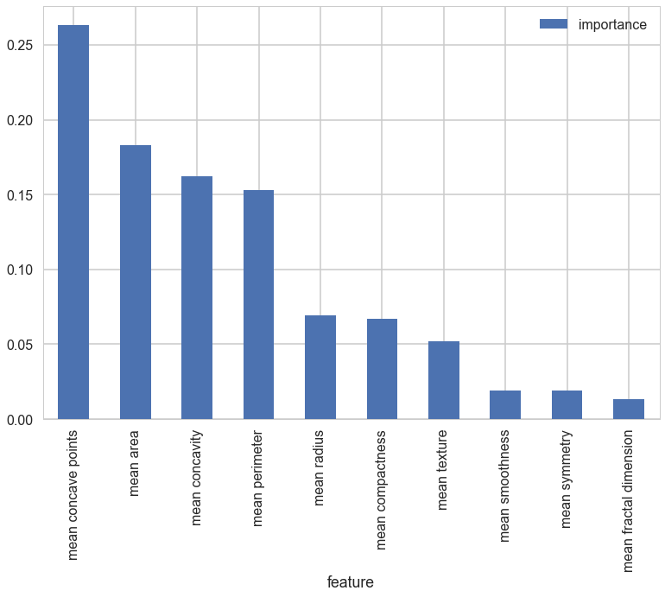

Figure X

Secondly, I did confusion matrix analysis. The columns are the diagnosis we predicted for the test data and the rows are the actual species for the test data.

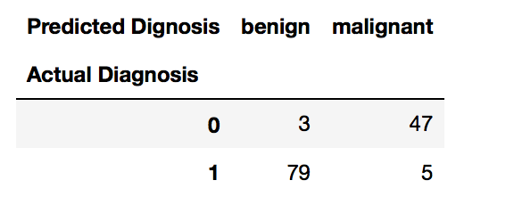

Figure X

**5. Thoughts and Conclusion**

**Citation**